During my time at CoLane Logistics, a Chicago tech startup, I extracted *user clicks and keystrokes* from the user logs of a proprietary application in Python, and I assigned the clicks and keystrokes to logistics brokerage transactions. Put succinctly, I counted the clicks and keystrokes per transaction. These metrics were used by the CoLane Logistics executive team to estimate labor cost per transaction.

* *Clicks Per Transaction (load):* Histogram of the number of clicks required to complete logistics brokerage transactions. The x-axis is the number of clicks required to complete logistics transactions. The y-axis is the number of transactions requiring the number of clicks specified by the x-axis.
* 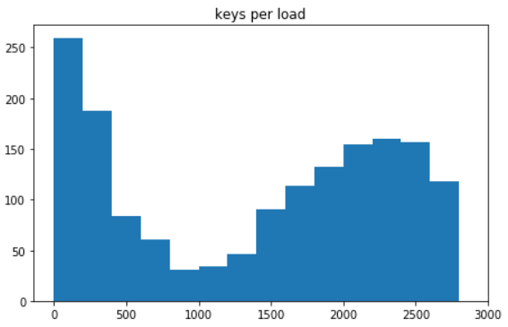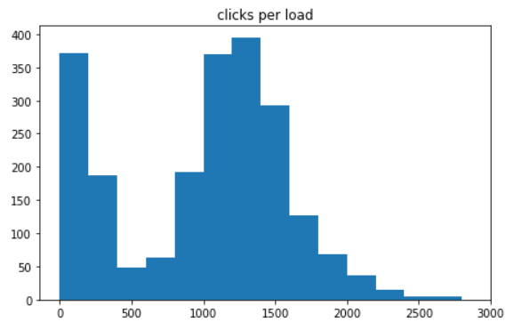*Keystrokes Per Transaction (load):* Histogram of the number of keystrokes required to complete logistics brokerage transactions. The x-axis is the number of keystrokes required to complete transactions. The y-axis is the number of transactions requiring the number of keystrokes specified by the x-axis.

Composed of nearly 200,000 trucking companies, the US long-haul trucking market is highly fragmented. Most of the market is controlled by medium-sized carriers, leaving room for consolidation. The following charts illustrate a breakdown of the market share. Each area represents the market share controlled by trucking companies of a specified size. A trucking company's size is the number of trucks (or *power units*) it owns. I extracted this data from FMCSA roadside and weigh-station truck inspections using Python. These data visualizations were used by the CoLane Logistics executive team to pitch to investors.

* 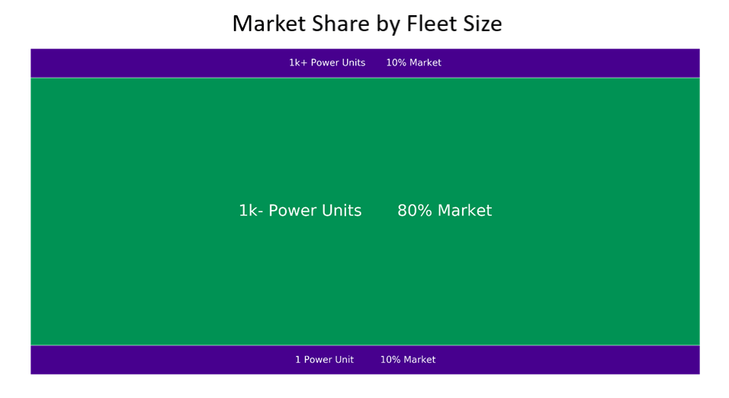*Market Share:* Breakdown of market share by trucking company size. 80% of the market share is controlled by trucking companies owning 2-999 trucks (or *power units*) per company. Only 10% of the market share is controlled by large companies having 1,000+ trucks per company, which signals an opportunity for consolidation in the middle market.
* *Market Share by Fleet Size:* Breakdown of market share by trucking company size. 33% of the market share is controlled by trucking companies (or *carriers*) owning 10-99 trucks per company. However, these companies make up just 7% of the total number of trucking companies, which signals an opportunity for brokerage activity.

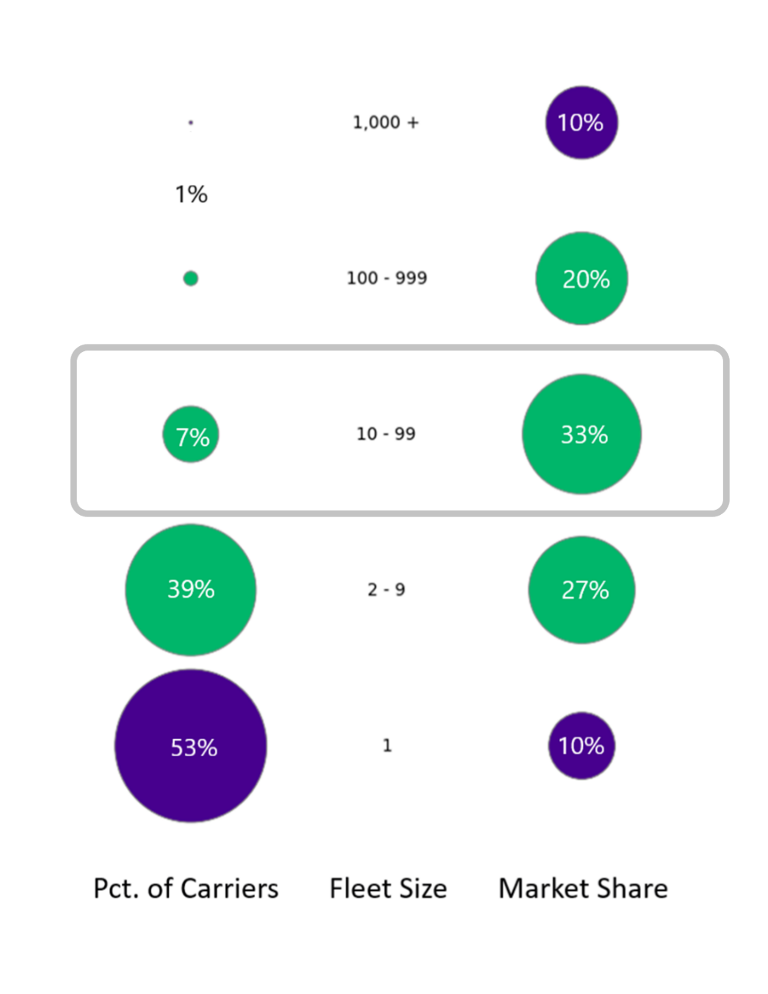

* *Market Share by Fleet Size:* Breakdown of market share by trucking company size. A significant portion of the market share is controlled by companies that own just 10-19 (or *10s* of) trucks per company.

